**CHAPTER 1**

**INTRODUCTION**

* 1. **OVERVIEW OF THE PROJECT**

This project explores the integration of **Intelligent Reflecting Surfaces (IRS)** with small-scale **MIMO wireless networks** to address the growing performance and energy-efficiency demands of next-generation communication systems. Targeting critical use cases such as IoT deployments, 5G/6G indoor hotspots, and urban coverage gaps, the IRS-assisted architecture leverages programmable metamaterials to dynamically manipulate electromagnetic wave propagation. Unlike traditional relay-based systems, IRS enables passive beamforming by adjusting the phase and amplitude of incident signals through tunable unit cells, without requiring active signal amplification.

When combined with compact 2×2 or 4×4 MIMO configurations, this approach delivers significant advantages: enhanced spectral efficiency via intelligent multipath control, mitigation of coverage dead zones in non-line-of-sight (NLOS) scenarios, and substantial reductions in power consumption. By transforming the wireless channel into a software-defined propagation environment, this technology represents a paradigm shift in how radio environments are engineered, offering scalable, low-power solutions for the high-density, high-throughput networks of the future.

**Personalization:** The system architecture includes adaptive control mechanisms that enable personalized wireless environments tailored to user-specific communication needs. Leveraging real-time beam steering and channel estimation powered by machine learning algorithms, the IRS-assisted MIMO system dynamically optimizes signal paths based on user location, device type, and traffic demand. For instance, IoT sensors requiring ultra-low power can be prioritized with energy-efficient paths, while high-throughput mobile users can benefit from optimized beamforming. This level of customization ensures that each user experiences consistent quality of service, making the system ideal for applications in smart homes, offices, and personalized IoT ecosystems.

**Globalization:** The project embraces globalization by designing a flexible, scalable, and region-agnostic communication architecture. The IRS-MIMO system supports multiple frequency bands, including sub-6GHz and mm Wave spectra, to meet regulatory and deployment requirements across different countries. Its compatibility with international wireless standards such as 5G NR and IEEE 802.11 ensures seamless integration into global infrastructure.

Furthermore, the use of software-defined radios and FPGA-based controllers enables rapid adaptation to regional needs, whether in densely populated urban centres, rural areas, or developing nations. This adaptability makes the technology a viable solution for global connectivity initiatives, including smart city rollouts and remote education.

**Multimedia Services:** IRS-assisted MIMO networks are especially well-suited for delivering high-quality multimedia services, including HD video streaming, real-time conferencing, AR/VR applications, and remote collaboration. By dynamically shaping the wireless channel and improving signal-to-noise ratio (SNR), the system reduces latency and jitter, critical factors for immersive media experiences.

The improved spectral efficiency and robust NLOS performance ensure consistent throughput in bandwidth-intensive applications, even in environments with multiple users and high interference levels. This makes the solution ideal for multimedia-rich settings like smart campuses, virtual event venues, and connected homes.

**Software Implementation:** The software implementation of this project is centered around COMSOL Multiphysics 6.3, which serves as the primary platform for simulating and analyzing the electromagnetic behavior of the IRS-MIMO system. COMSOL enables full-wave modeling of the metamaterial-based IRS structures, capturing complex physical effects such as near-field coupling, surface wave propagation, and frequency-dependent material properties.

The simulation environment is used to optimize the design of tunable unit cells, evaluate phase-shifting behavior, and analyze system-level performance under various propagation scenarios, including non-line-of-sight (NLOS) conditions. Coupled with MATLAB and Python for control logic and post-processing, the simulation framework supports multi-physics co-simulation, integrating electromagnetic, thermal, and structural aspects to ensure robust, real-world performance. This comprehensive approach allows accurate prediction of system behavior and guides hardware design and prototyping decisions, ensuring that the software foundation directly translates into practical implementation success.

* 1. **WIRELESS COMMUNICATION**

Wireless communication is the transfer of information between two or more devices without the use of physical conductors, relying instead on electromagnetic waves to transmit signals across distances. It forms the backbone of modern connectivity, enabling technologies such as mobile networks, Wi-Fi, satellite systems, and IoT applications. In wireless systems, data is typically modulated onto carrier waves in various frequency bands (e.g., sub-6GHz, mm Wave) and transmitted through free space, where it may encounter obstacles, reflection, scattering, and interference.

The increasing demand for high-speed, low-latency, and energy-efficient communication in densely populated and dynamic environments has driven the evolution of wireless technologies. In the context of this project, wireless communication is enhanced through the integration of small-scale MIMO systems and Intelligent Reflecting Surfaces (IRS), which collaboratively manipulate signal propagation to improve coverage, spectral efficiency, and reliability without increasing transmission power or infrastructure complexity.

* 1. **WIRELESS TECHNOLOGY**

Wireless technology encompasses the various methods and standards used to transmit data over the air using electromagnetic signals, eliminating the need for physical connections like cables or fibre optics. It includes a wide range of applications—from mobile networks (2G to 6G), Wi-Fi (IEEE 802.11), and Bluetooth, to satellite communications and emerging IoT protocols such as LoRa and Zigbee.

The evolution of wireless technology has been marked by advancements in bandwidth efficiency, data rates, latency reduction, and energy optimization. Modern wireless technologies rely heavily on techniques such as Multiple Input Multiple Output (MIMO), Orthogonal Frequency Division Multiplexing (OFDM), and beamforming to enhance performance in complex environments. In this project, wireless technology is further advanced through the implementation of Intelligent Reflecting Surfaces (IRS), which act as programmable passive elements that intelligently control signal reflection, enabling dynamic reconfiguration of the wireless environment. This synergy with small-scale MIMO systems enables a new generation of adaptive, efficient, and high-performance wireless communication networks suitable for next-generation applications like 5G/6G, smart cities, and industrial automation.

* 1. **WIRELESS COMMUNICATION STANDARD**

Wireless communication standards are a set of protocols and guidelines that govern the design, operation, and interoperability of wireless communication systems. These standards ensure that devices, networks, and systems can communicate effectively and reliably across different technologies and platforms. The most widely adopted standards in modern wireless communication include 2G, 3G, 4G LTE, and 5G for mobile networks, Wi-Fi (IEEE 802.11) for local area networks, and Bluetooth (IEEE 802.15.1) for short-range communication. Each standard defines key aspects such as frequency bands, modulation techniques, data rates, and error correction methods to optimize performance.

The evolution of these standards has been driven by the increasing demand for higher data rates, lower latency, and more reliable connectivity, particularly in dense environments and emerging applications such as IoT and smart cities. The transition to 5G and the future of 6G involve new technologies like Massive MIMO, beamforming, and Intelligent Reflecting Surfaces (IRS), which aim to address the limitations of current systems. In this context, the integration of IRS with MIMO systems represents a key innovation to enhance spectral efficiency, network capacity, and user experience, aligning with the next generation of wireless communication standards.

**Fig 1.4 EVALUATION OF 1G TO 6G WIRELESS COMMUNICATION**

* 1. **5G/6G GENERATION**

The 5G generation represents a major leap forward in wireless communication, designed to meet the demands of high-speed internet, low latency, and massive connectivity required by applications such as autonomous vehicles, smart cities, and the Internet of Things (IoT). It introduces several key innovations, including massive MIMO (Multiple Input Multiple Output), beamforming, network slicing, and millimetre-wave (mm Wave) technology. These advancements allow 5G networks to support ultra-high-speed data rates (up to 10 Gbps), significantly reduced latency (as low as 1 ms), and the capacity to connect millions of devices in a given area, facilitating the growth of IoT ecosystems and connected environments. Furthermore, 5G enables low latency communication crucial for mission-critical applications like industrial automation and remote surgery.

Looking ahead, 6G will usher in an even more transformative era of wireless communication. It aims to build upon 5G's capabilities and will likely support data rates in excess of 100 Gbps, ultra-reliable low-latency communication (URLLC), and massive machine-type communications (mMTC). 6G is expected to integrate terahertz (THz) communication, AI-driven network management, and holographic communications for applications such as immersive augmented and virtual reality (AR/VR), smart healthcare, and real-time 3D mapping. Additionally, Intelligent Reflecting Surfaces (IRS) and reconfigurable intelligent surfaces (RIS) will play a crucial role in the 6G landscape by enabling flexible and adaptive wireless environments that enhance signal quality and reduce interference, leading to better user experience and network efficiency. The transition from 5G to 6G will focus on increasing both the capacity and intelligence of the network to accommodate the ever-growing demand for ubiquitous, high-speed, low-latency connectivity across diverse environments.

* 1. **MIMO AND TYPES**

Multiple Input Multiple Output (MIMO) is a crucial technology in modern wireless communication that utilizes multiple antennas at both the transmitter and receiver to improve data throughput, signal reliability, and network capacity. MIMO works by exploiting multipath propagation, where signals bounce off surfaces, allowing multiple versions of the same signal to reach the receiver. The receiver then separates these signals to increase data transmission without needing additional spectrum. MIMO is particularly useful in high-demand environments, such as urban and indoor spaces, where signal degradation and interference are common. It is a cornerstone technology for 4G LTE, 5G, and beyond.

There are several types of MIMO systems, each suited to different communication environments and performance requirements:

**Single-User MIMO (SU-MIMO):** This type focuses on providing high throughput for a single user by utilizing multiple transmit and receive antennas to send and receive multiple data streams simultaneously. It improves the data rate and reliability for users in areas with poor signal conditions, such as urban and indoor environments.

**Multi-User MIMO (MU-MIMO):** Unlike SU-MIMO, which serves one user at a time, MU-MIMO allows multiple users to share the same time-frequency resources. It increases network capacity and overall efficiency by serving several users simultaneously in a cellular environment, reducing congestion and improving system performance.

**Massive MIMO:** This is an advanced version of MIMO that employs a large number of antennas (often hundreds or thousands) at the base station. Massive MIMO boosts spectral efficiency, reduces interference, and improves coverage, making it especially useful for 5G and future 6G networks. It can support hundreds of users concurrently with improved signal quality and reliability.

**Spatial MIMO:** This type of MIMO uses the spatial diversity provided by multiple antennas to send signals through different spatial channels. It is beneficial for improving the signal-to-noise ratio (SNR) in environments with high interference or fading.

Each of these MIMO types contributes to the advancement of wireless communication systems, particularly as the demand for high-speed, reliable, and scalable networks continues to grow. The integration of MIMO with technologies such as Intelligent Reflecting Surfaces (IRS) further enhances performance by improving signal propagation, beamforming, and coverage, especially in complex and dynamic environments.

* 1. **IRS DETAILS**

Intelligent Reflecting Surfaces (IRS) are an emerging technology in wireless communication that offer a novel way to enhance signal propagation by intelligently controlling the reflection of electromagnetic waves in the environment. IRS consists of large arrays of passive, reconfigurable elements that can adjust the phase and amplitude of incoming signals without the need for active amplification or transmission power. These surfaces are typically composed of meta-materials, which are engineered to manipulate electromagnetic waves in a controlled manner, allowing for dynamic beam steering and signal optimization. IRS devices can be made of cost-effective components such as PIN diodes or varactors, which enable precise control of signal reflection and phase shifting.

The key advantage of IRS lies in its ability to transform the wireless environment into a software-defined space. By reconfiguring the propagation path of signals, IRS enhances spectral efficiency, signal-to-noise ratio (SNR), and coverage while reducing interference. This makes it particularly valuable for non-line-of-sight (NLOS) conditions, where traditional communication systems may suffer from poor signal quality due to obstacles like buildings or walls. IRS also offers significant improvements in energy efficiency compared to traditional relay systems, as it consumes much less power by passive reflection rather than active signal amplification.

In practice, IRS can be deployed in various environments such as urban settings, indoor areas, and smart factories, where it helps mitigate common challenges like multipath fading and signal blockages. When integrated with small-scale MIMO systems, IRS significantly boosts the area spectral efficiency, improving throughput and capacity for IoT, 5G, and even emerging 6G networks. The integration of IRS with beamforming and machine learning algorithms enables real-time optimization of wireless channels, adapting to dynamic conditions and user mobility. In the long term, IRS is expected to play a pivotal role in the development of future wireless communication systems by enabling flexible, high-capacity, and energy-efficient networks.

* 1. **COMSOL MULTIPHYSICS 6.3**

COMSOL Multiphysics 6.3 is a powerful simulation software platform used for modelling and simulating a wide range of physical phenomena, including electromagnetics, fluid dynamics, structural mechanics, and heat transfer. It is particularly well-suited for multi-physics simulations, where interactions between different physical fields are critical. In the context of this project, COMSOL Multiphysics is utilized to model and analyse the performance of Intelligent Reflecting Surfaces (IRS) integrated with small-scale MIMO systems for wireless communication applications.

Using COMSOL, we can conduct full-wave electromagnetic simulations to evaluate the behaviour of IRS structures, which are composed of reconfigurable meta-material elements that manipulate electromagnetic waves. The software allows us to study the effects of phase shifting, signal reflection, and beamforming at various frequencies, such as sub-6 GHz and millimetre-wave (mm Wave) bands, which are key for IoT and 5G/6G networks. COMSOL’s RF Module is particularly useful for simulating the propagation of electromagnetic waves in complex environments, taking into account near-field interactions, material dispersion, and the impact of obstacles or non-line-of-sight conditions.

The parametric sweep and optimization tools in COMSOL Multiphysics 6.3 enable the fine-tuning of IRS configurations to maximize performance metrics such as spectral efficiency, signal-to-noise ratio (SNR), and coverage. Additionally, electromagnetic wave coupling can be simulated in the presence of real-world constraints like antenna placement, environmental factors, and channel characteristics. The software's user-friendly interface, combined with its powerful solvers, allows for iterative testing and modification of design parameters, ensuring a comprehensive and efficient approach to the development of IRS-assisted MIMO systems.

By using COMSOL Multiphysics 6.3 for system-level simulations, we are able to validate the theoretical predictions, assess potential design issues, and optimize IRS configurations for practical deployment in real-world environments, such as indoor and urban settings where wireless performance is often hindered by interference and signal degradation.

* 1. **SCOPE OF THE PROJECT**

The scope of this project centres on the design, simulation, and evaluation of an **Intelligent Reflecting Surface (IRS)-assisted small-scale MIMO wireless communication system** using **COMSOL Multiphysics 6.3**. The primary objective is to explore how IRS technology can significantly enhance wireless signal propagation, spectral efficiency, and energy performance in environments where traditional MIMO systems face challenges, such as indoor spaces, urban areas, and IoT-dense networks. The project covers the modelling of tunable IRS elements, full-wave electromagnetic simulation of wave interactions, and performance analysis under different propagation conditions.

It also investigates the integration of IRS with 2×2 and 4×4 MIMO configurations, focusing on metrics such as signal-to-noise ratio (SNR), coverage improvement, and system power consumption. The scope extends to practical considerations like hardware feasibility, phase shift quantization, and real-time channel adaptation using intelligent control mechanisms.

Overall, this project contributes to the advancement of 5G and future 6G technologies by demonstrating the potential of IRS to transform passive wireless environments into dynamically controllable communication channels.

* 1. **OBJECTIVE**

The primary objective of this project is to design and implement an **Intelligent Reflecting Surface (IRS)-assisted small-scale MIMO wireless communication system** to improve wireless signal performance in complex environments.

The project aims to demonstrate how IRS can enhance **spectral efficiency**, **signal coverage**, and **energy efficiency** by intelligently manipulating the propagation of electromagnetic waves.

Using **COMSOL Multiphysics 6.3**, the project seeks to model IRS structures, analyse wave reflection and phase control, and optimize the overall system performance under various channel conditions. Additional objectives include reducing power consumption, addressing non-line-of-sight (NLOS) communication challenges, and ensuring compatibility with existing 5G/6G and IoT infrastructures.

**CHAPTER 2**

**LITERATURE SURVEY**

This chapter gives technical survey on some previous works. Some concepts related to the proposed work are mentioned as follows.

1. Qingqing Wu, Shuowen Zhang, Beixiong Zheng, Changsheng You, and Rui

Zhang, **“Intelligent Reflecting Surface-Aided Wireless Communications”** (2021).

**Objective:**

The paper aims to explore **Intelligent Reflecting Surfaces (IRS)** as a transformative technology for improving wireless communication in future networks like **5G and 6G**. It focuses on optimizing passive beamforming, improving channel estimation, and enabling energy-efficient deployment.

**Methodology:**

A tutorial-based approach is used, covering theoretical signal models, IRS hardware behaviour, and system integration. The authors apply optimization techniques (e.g., alternating optimization) to configure IRS phase shifts and transmit beamforming, with analysis across SISO, MIMO, and OFDM systems.

**Performance Measured:**

Key performance metrics include **SNR**, **achievable rate**, **power efficiency**, and **beamforming gain**. The study shows that IRS can significantly enhance signal strength and reduce energy consumption, especially in non-line-of-sight (NLoS) conditions.

**Suggestions:**

Future research should address more realistic channel models, precise IRS control hardware, and low-complexity algorithms for dynamic beamforming. Integration with **THz communication**, **AI-based control**, and **massive MIMO** is recommended for future 6G systems.

1. Wei Lu, Bin Deng, Qiqing Fang, Xiaoqiao Wen, and Shixin Peng, **“Intelligent**

**Reflecting Surface-Enhanced Target Detection in MIMO Radar” (2021).**

**Objective:**

This paper investigates the use of **Intelligent Reflecting Surfaces (IRS)** to enhance target detection in **collocated MIMO radar systems**. The main objective is to improve received signal power and detection accuracy by optimizing IRS-assisted beamforming, thus enabling sharper angle estimation and better spatial resolution in radar applications.

**Methodology:**

The authors propose an **IRS-assisted target detection algorithm** that optimizes IRS phase shifts based on SNR criteria using a practical hardware model. They use a modified **Amplitude and Phase Estimation (APES)** method for target detection and derive closed-form solutions for suboptimal IRS configurations. The study includes detailed channel modelling with Rician fading and a CRB-based performance analysis.

**Performance Measured:**

Performance is evaluated using **Cramér–Rao Bound (CRB)**, **SNR**, **detection probability**, and **spatial spectral resolution**. Simulations show that the IRS-enhanced radar achieves better detection accuracy and finer angle resolution, especially as the number of IRS elements increases. A lower Rician factor (closer to Rayleigh fading) yields better performance due to reduced channel degradation.

**Suggestions:**

The study suggests using **Rayleigh channels** for IRS-to-receiver links to maximize performance. It also recommends minimizing control overhead via **discrete phase shifts** and emphasizes the importance of practical IRS hardware modelling. Future work may explore IRS placement strategies and broader applications in adaptive radar systems.

1. Zheng Li, Zhengyu Zhu, Zheng Chu, Yingying Guan, De Mi, Fan Liu, Lie Liang Yang, **“IRS-Assisted Integrated Sensing and Wireless Power Transfer”**

(2023).

**Objective:**

This paper investigates an **IRS-assisted integrated sensing and wireless power transfer (ISWPT)** system aimed at smart transportation infrastructure. The objective is to simultaneously achieve efficient **target sensing** and **RF energy harvesting** by optimizing the system’s beamforming and IRS phase shifts under practical constraints.

**Methodology:**

The authors formulate a non-convex optimization problem to balance the trade-off between sensing accuracy and harvested energy, using a **trade-off factor (ρ)**. Two solutions are proposed: a **semi-definite programming (SDP)** method and a **low-complexity (LC)** algorithm that combines **successive convex approximation (SCA)** for beamforming and **majorization-minimization (MM)** for phase control. These solutions address the coupling between transmit and reflection variables.

**Performance Measured:**

Key performance metrics include **sum harvested energy**, **beampattern gain**, and **algorithm convergence rate**. Simulations show that both SDP and LC methods converge rapidly (within 2–3 iterations) and significantly outperform baseline methods without IRS or with random phase shifts. The harvested energy increases with IRS element count, and optimal phase tuning yields sharp target localization.

**Suggestions:**

The authors recommend deploying more IRS elements for better resolution and energy performance. They also highlight the importance of phase shift optimization and suggest future studies on **adaptive IRS placement**, **dynamic environmental modelling**, and **joint waveform design** for enhanced ISWPT performance.

1. Yuan Zheng, Suzhi Bi, Ying Jun (Angela) Zhang, Zhi Quan, and Hui Wang,

**“Intelligent Reflecting Surface Enhanced User Cooperation in Wireless Powered**

**Communication Networks”** (2020).

**Objective:**

The paper investigates the use of **Intelligent Reflecting Surfaces (IRS)** in **Wireless Powered Communication Networks (WPCNs)** to improve throughput. It focuses on optimizing the IRS phase shifts, power, and time allocation to enhance energy harvesting and data transmission between a **High-Altitude Platform (HAP)** and **Wireless Devices (WDs)**.

**Methodology:**

The system model involves two WDs cooperating via IRS to relay signals. The problem is formulated as an optimization task to maximize throughput, which is solved using **Semidefinite Programming (SDP)** and convex optimization tools like **CVX**. Rank-one constraints are relaxed, and suboptimal solutions are derived to recover phase shifts and power allocations.

**Performance Measured:**

Simulation results show that IRS-assisted cooperation provides up to **652%** higher throughput than conventional methods. The performance improves with more IRS elements, but the gains decrease when inter-user channels weaken. Different distances between HAP and WDs are evaluated, showing the effectiveness of IRS in mitigating weak channel conditions.

**Suggestions:**

Future work can focus on **multi-user WPCNs**, where users share energy and relay information. Challenges like **discrete-phase IRS** and real-time optimization need further exploration for practical implementations. The integration of IRS in **5G/6G** could enhance network efficiency and reduce costs.

**CHAPTER 3**

**EXISTING AND PROPOSED SYSTEM**

* 1. **EXISTING SYSTEM**

In traditional Wireless Sensor Networks (WSNs), data transmission systems often suffer from limitations that affect performance and reliability. These networks, made up of multiple sensor nodes, are used to monitor environmental parameters but face challenges like interference, fading, and signal blockage—especially in urban or remote areas. Multipath fading caused by obstacles can distort signals and cause delays.

Conventional WSNs also have restricted data rates and low spectral efficiency due to limited bandwidth and basic communication protocols. Most sensor nodes operate on low power, which limits their ability to handle high data traffic or real-time applications. Battery limitations and energy waste through retransmissions or idle listening further reduce network lifespan.

Moreover, WSNs lack the adaptability to changing conditions, as they often cannot reconfigure intelligently or optimize transmission. These drawbacks impact accuracy, increase latency, and reduce scalability in larger or mission-critical deployments.

* + 1. **DISADVANTAGE**
* **High Energy Consumption**

Base stations and towers consume significant power, especially in rural or remote areas.

* **Coverage Gaps**

Difficult to provide reliable connectivity in complex environments like tunnels, basements, or mountainous regions.

* **High Deployment Cost**

Installing and maintaining base stations and towers is expensive.

* **Signal Blockage**

Obstacles such as buildings and terrain reduce signal quality through reflection and absorption.

* **Interference Issues**

Crowded frequency bands cause signal degradation due to overlapping transmissions.

* **Inefficient Spectrum Use**

Traditional networks cannot dynamically allocate spectrum based on real-time needs.

* **Latency Problems**

Long signal paths and congestion lead to delays in data transmission.

* **Environmental Impact**

Tower construction and electronic waste pose environmental challenges.

* **Security Vulnerabilities**

Centralized infrastructure increases exposure to cyberattacks and data breaches.

* **Scalability Limitations**

Hard to scale in growing urban or industrial environments without large infrastructure upgrades.

* 1. **PROPOSED SYSTEM**

The proposed system integrates Multiple-Input Multiple-Output (MIMO) antenna-equipped sensor nodes within a wireless network, strategically distributed to monitor and optimize signal transmission in challenging environments. These nodes are capable of measuring signal strength, Channel State Information (CSI), and interference patterns in real time. Additionally, RF sensors are deployed to collect detailed data on multipath propagation, fading conditions, and other environmental effects that typically degrade signal quality.

To counteract these impairments, the system leverages advanced signal processing techniques such as beamforming and precoding, which allow for directed signal transmission, reducing interference and improving reliability. Machine learning models are incorporated to detect, classify, and mitigate interference dynamically. Furthermore, the system enables the real-time adjustment of antenna parameters, allowing it to respond adaptively to environmental changes and optimize communication paths for improved network efficiency.

This intelligent, adaptive architecture represents a significant step toward next-generation wireless networks, offering enhanced performance, reliability, and energy efficiency.

* + 1. **ADVANTAGE**
* **Enhanced Signal Quality**

Real-time monitoring of signal strength and CSI allows for optimized data transmission, minimizing packet loss and distortion.

* **Improved Spectral Efficiency**

Beamforming and precoding techniques focus energy where it's needed, reducing spectrum wastage and enhancing throughput.

* **Adaptive Interference Mitigation**

Machine learning-based detection enables proactive management of interference sources, which is difficult in static traditional systems.

* **Better Multipath Handling**

MIMO and RF sensing allow the system to exploit or mitigate multipath effects rather than suffer from them, leading to higher reliability.

* **Dynamic Network Reconfiguration**

The system can adapt antenna orientation, power, and signal parameters in real time, something fixed tower-based systems cannot do.

* **Energy Efficiency**

Focused beam transmission and fewer retransmissions help reduce the power consumption of sensor nodes, extending operational life.

* **Scalability**

The modular design and intelligent coordination allow easy network expansion without sacrificing performance.

* **Reduced Latency**

By optimizing transmission paths and avoiding congestion zones through learning-based routing, data reaches the destination faster.

* **Smaller Physical Footprint**

Unlike towers, this system can be deployed on existing infrastructure (walls, poles, buildings), minimizing visual and environmental impact.

* **Resilience to Environmental Changes**

The system continuously learns and adapts to new channel conditions, making it robust to terrain or weather-related disruptions.

**CHAPTER 4**

**SYSTEM DESIGN**

* 1. **BLOCK DIAGRAM**



**Fig 4.1 BLOCK DIAGRAM**

* 1. **DESCRIPTION**

**1. IRS Controller and Control Circuit**

The operation of the intelligent reflecting surface (IRS) system starts with the IRS Controller, which is typically implemented using a microcontroller or embedded processor such as a Raspberry Pi or FPGA. This component is tasked with monitoring, processing, and issuing configuration commands to control the reflective properties of the IRS panel. It serves as the brain of the IRS system, enabling adaptive beamforming and signal steering based on real-time channel conditions and user locations.

Connected directly to the IRS Controller is the Control Circuit, which converts the digital control signals into the required analog signals (such as voltage levels) that adjust the phase or amplitude response of each reflecting element in the IRS panel. This circuit ensures that each of the N reflecting elements on the IRS panel can be finely tuned for optimal performance. The dynamic control mechanism allows the IRS to function intelligently and flexibly in a changing wireless environment, such as user mobility, signal blockage, or interference.

**2. IRS Panel with N Elements**

The IRS Panel, consisting of N discrete reflecting elements, acts as a passive but intelligent medium to manipulate incoming wireless signals. These elements are designed with tunable components (e.g., PIN diodes, varactors, or MEMS switches) that allow control over the phase, amplitude, or polarization of reflected signals. The elements are arranged in a grid-like fashion to form a reconfigurable meta surface.

When signals from the base station impinge upon the IRS panel, the Control Circuit—under the supervision of the IRS Controller—modifies the surface reflection properties of each IRS element to form a directional beam toward intended user locations. This process is often referred to as passive beamforming. Unlike traditional active antennas, the IRS does not require power-hungry RF chains or signal generation, making it a highly energy-efficient solution for enhancing signal coverage and reliability.

Thus, the IRS Panel serves a dual purpose: (1) it receives control instructions from the IRS Controller to reconfigure its elements, and (2) it reflects the incident signals from the base station in desired directions to serve users, even in non-line-of-sight (NLOS) conditions.

**3. Base Station**

The Base Station (BS) is the central transmission point in the wireless communication system. It generates and transmits downlink signals intended for multiple users. However, in dense urban or indoor environments, direct communication paths between the base station and users may be partially or fully obstructed, limiting the base station’s ability to maintain a reliable link with all users.

To overcome this, the base station also transmits signals towards the IRS panel, which acts as a signal repeater or reflector. By carefully designing the signal path through the IRS, the system can circumvent physical obstacles and provide indirect but optimized communication links to users. The base station and IRS thus work in tandem—one actively transmitting signals and the other intelligently redirecting them.

**4. Blocking Agent**

Between the base station and the users exists a Blocking Agent, such as a wall, building, tree, or any large object that obstructs the Line-of-Sight (LOS) signal path. This blocking agent introduces a Non-Line-of-Sight (NLOS) communication environment, which degrades signal strength and quality. Users located behind the blockage may experience low signal-to-noise ratio (SNR), increased latency, and lower throughput, ultimately impairing the quality of service.

This challenge is what motivates the use of IRS technology. While traditional methods like signal relays or higher transmission power may provide limited improvements, they also consume more energy and resources. The IRS, by contrast, offers a passive and energy-efficient alternative to re-establish communication links disrupted by the blocking object.

**5. Users**

The Users, represented as end devices such as smartphones, IoT nodes, or laptops, are the final recipients of the transmitted signals. In scenarios where direct signal paths are blocked, the users rely on the IRS to receive a strong and coherent signal. The IRS reflects and reshapes the signal beams such that the signal energy is constructively directed toward the user locations, compensating for path loss and improving signal coverage.

This re-routed signal path ensures that users who are in a shadow region (due to the blocking object) can still achieve high data rates and reliable connectivity, without requiring additional infrastructure. The ability of the IRS to adapt its reflection pattern in real time allows it to support multiple users simultaneously, each potentially requiring a unique signal path.

**System Summary**

The entire system operates in a synchronized manner to mitigate the effects of physical obstructions and enhance wireless communication. The Base Station transmits the original signal, which is intercepted by a Blocking Agent and fails to reach users directly. Simultaneously, this signal is also directed towards the IRS Panel, which, under the guidance of the IRS Controller and Control Circuit, reconfigures its elements to reflect the signal toward the intended Users. As a result, the system enables seamless and energy-efficient communication in otherwise unreachable NLOS scenarios.

**CHAPTER 5**

**HARDWARE REQUIREMENTS**

The hardware requirements and their data sheets we needed in our projects is given below

* Power Supply
* Arduino UNO Microcontroller
* Capacitor 3pF
* Inductor 6nH
* Varactor Diode
* Voltage Regulator
* IRS Panel with Tuneable Elements
* RF Transmitter & Receiver
* Wi-Fi Transmitter & Receiver
* Tower
* Antenna
* Battery

These are the hardware tools we required to get the result of reducing multiple antennas. Their descriptions are follows:

**5.1 POWER SUPPLY**

The Arduino UNO operates using an ATmega328P microcontroller, which requires a regulated 5V DC supply. The board, however, is designed to be flexible and can be powered in multiple ways:

* Through the USB port
* Via the external DC power jack (barrel jack)
* Using the Vin pin directly on the board

Each power input method comes with specific operational ranges and internal regulation paths to ensure the microcontroller always receives the correct voltage.

**a) USB Power Supply (5V DC)**

* This is the most common power source when the board is connected to a computer or a USB power adapter.
* Provides a direct 5V input regulated by the USB power source.
* Suitable for low-power applications and debugging.
* 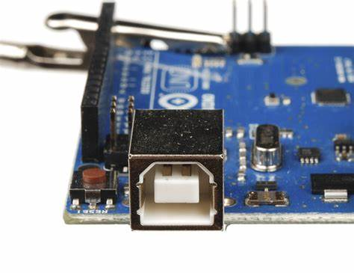Current is typically limited to 500 mA from a standard USB port.

**b) External DC Power Supply (Barrel Jack)**

* The Arduino UNO includes a standard **2.1mm centre-positive barrel jack** that accepts input voltages from **7V to 12V** (recommended).
* Internally, the board uses a **linear voltage regulator** (such as the **NCP1117**) to step this voltage down to 5V.
* Useful for standalone applications or where USB power is not available.
* 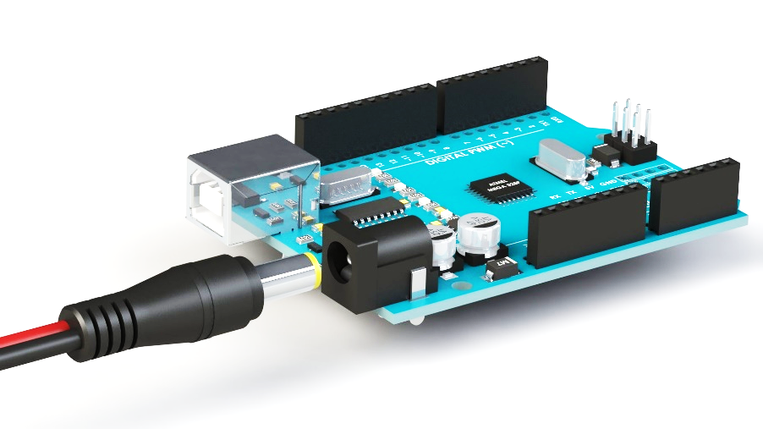Can typically provide more current than USB alone.

**c) Vin Pin**

* An alternate method to power the board is to supply **7V to 12V** directly to the **Vin pin**.
* This voltage is regulated down by the same onboard linear regulator.
* 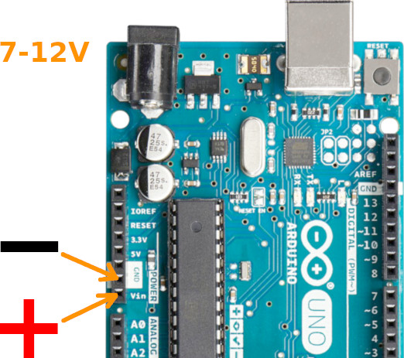Often used when integrating the Arduino into custom power circuits.

**Onboard Voltage Regulation**

The Arduino UNO features a built-in **voltage regulator** to ensure stable 5V operation regardless of minor fluctuations in input voltage. The regulator typically used is:

* **NCP1117 (Low Dropout Linear Regulator)**
  + Input Voltage Range: 7V–12V
  + Output Voltage: 5V
  + Output Current Capacity: Up to 800 mA
  + Features: Thermal overload protection, short circuit protection, and low dropout voltage

This regulator ensures that even if there are small surges or drops in the input voltage, the microcontroller and connected components will continue to operate reliably.

**Voltage Regulator**

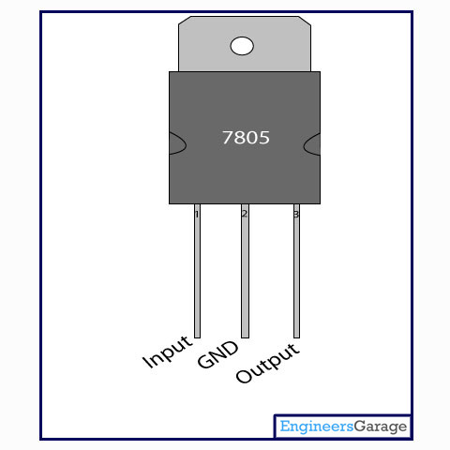

The IC 7805 is a type of voltage regulator that provides a fixed 5V DC output from a higher voltage input, typically between 7V and 12V. It is part of the 78xx series of regulators and is widely used in electronic circuits to power 5V devices like microcontrollers, sensors, and modules. The IC has three pins: input, ground, and output. It also includes built-in features like thermal overload protection, short-circuit protection, and voltage regulation, ensuring a stable and reliable 5V supply.

**5.2 ARDUINO UNO MICROCONTROLLER**

The Arduino UNO is one of the most popular and beginner-friendly microcontroller development boards in the world of embedded systems and electronics. It is widely used in academic, hobbyist, and industrial projects due to its simplicity, open-source hardware design, and extensive community support.

**Overview**

The Arduino UNO is based on the **ATmega328P microcontroller** developed by Atmel (now part of Microchip). It offers a simple platform for building digital devices that can sense, control, and interact with the physical world.

* **Microcontroller:** ATmega328P
* **Operating Voltage:** 5V
* **Input Voltage (recommended):** 7V – 12V
* **Digital I/O Pins:** 14 (of which 6 can provide PWM output)
* **Analog Input Pins:** 6
* **DC Current per I/O Pin:** 20 mA
* **Flash Memory:** 32 KB (0.5 KB used by bootloader)
* **SRAM:** 2 KB
* **EEPROM:** 1 KB
* **Clock Speed:** 16 MHz

**Key Components**

* **USB Port:** Used to connect the Arduino to a PC for programming and communication.
* **Power Jack:** For powering the board through an external power supply (7V–12V recommended).
* **Reset Button:** Resets the microcontroller; useful for restarting the program.
* **Voltage Regulator:** Converts input voltage to a steady 5V for the microcontroller.
* **Crystal Oscillator (16 MHz):** Provides the clock signal required for timing functions.
* **Digital I/O Pins:** Used for interfacing with digital components like LEDs, motors, and sensors.
* **Analog Input Pins:** Used for reading analog signals like temperature, light, or pressure.
* **ICSP Header:** For programming the microcontroller directly using an external programmer.
* **TX/RX LEDs:** Indicate data transmission (TX) and reception (RX) over USB.

**Programming and Software**

Arduino UNO is programmed using the **Arduino IDE** (Integrated Development Environment), which uses a simplified version of C/C++. The board connects to the computer via USB, and code (called a **sketch**) is uploaded using the bootloader already present on the ATmega328P.

The Arduino platform supports a wide range of **libraries** and **example codes**, making it easy to interface with components like sensors, displays, motors, and wireless modules.

**Applications**

* IoT (Internet of Things) Prototypes
* Home Automation
* Robotics
* Environmental Monitoring
* Educational Kits
* Sensor-Based Projects
* Wireless Communication (with Wi-Fi/Bluetooth modules)

**Advantages**

* Easy to use and beginner-friendly
* Wide availability and low cost
* Strong community support and open-source hardware
* Supports rapid prototyping
* Compatible with numerous sensors and modules

**Limitations**

* Limited memory and processing power for large or complex tasks
* Not suitable for real-time or high-speed processing
* Not ideal for industrial-grade or long-term embedded systems without external enhancements.

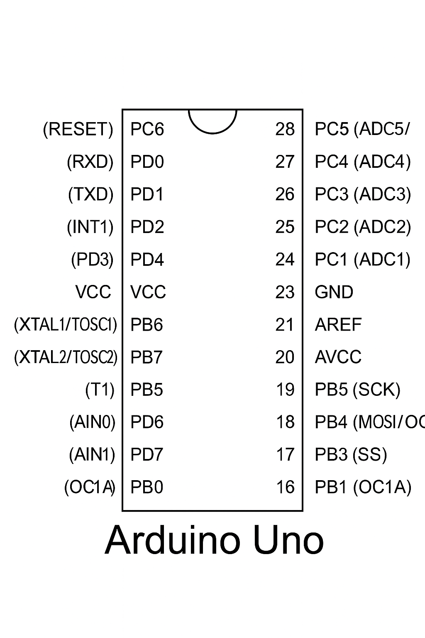**5.2.1 PIN DIAGRAM**

**Fig 5.2.1 PIN Diagram of ARDUINO UNO**

**5.2.2 PIN CONFIGURATION OF ARDUINO**

|  |  |  |
| --- | --- | --- |
| **Pin Number** | **Pin Name** | **Description** |
| 0 | RX | Serial receive pin (UART communication) |
| 1 | TX | Serial transmit pin (UART communication) |
| 2 | Digital Pin 2 | Digital I/O pin |
| 3 | Digital Pin 3 (PWM) | Digital I/O with PWM output |
| 4 | Digital Pin 4 | Digital I/O pin |
| 5 | Digital Pin 5 (PWM) | Digital I/O with PWM output |
| 6 | Digital Pin 6 (PWM) | Digital I/O with PWM output |
| 7 | Digital Pin 7 | Digital I/O pin |
| 8 | Digital Pin 8 | Digital I/O pin |
| 9 | Digital Pin 9 (PWM) | Digital I/O with PWM output |
| 10 | Digital Pin 10 (PWM) | Digital I/O with PWM output (also SPI SS) |
| 11 | Digital Pin 11 (PWM) | Digital I/O with PWM output (also SPI MOSI) |
| 12 | Digital Pin 12 | Digital I/O pin (also SPI MISO) |
| 13 | Digital Pin 13 | Digital I/O pin (built-in LED, SPI SCK) |
| A0 | Analog Pin A0 | Analog input pin (also digital I/O) |
| A1 | Analog Pin A1 | Analog input pin (also digital I/O) |
| A2 | Analog Pin A2 | Analog input pin (also digital I/O) |
| A3 | Analog Pin A3 | Analog input pin (also digital I/O) |
| A4 | Analog Pin A4 (SDA) | Analog input / I2C data line |
| A5 | Analog Pin A5 (SCL) | Analog input / I2C clock line |
| - | VIN | External voltage input (7V–12V recommended) |
| - | 5V | Regulated 5V output |
| - | 3.3V | Regulated 3.3V output |
| - | GND | Ground (multiple pins available) |
| - | RESET | Reset pin (manual or external reset) |
| - | IOREF | Voltage reference for shields |
| - | AREF | Analog reference voltage for ADC |

**Table 5.2.2 PIN CONFIGURATION OF ARDUINO**

**5.2.3 FEATURES OF ARDUINO UNO**

* Based on the ATmega328P microcontroller.
* Operates at **5V logic level**.
* 14 digital I/O pins (6 with PWM capability).
* 6 analog input pins.
* Clock speed: **16 MHz**
* Built-in USB interface for easy programming.
* Onboard LED on digital pin 13.
* 32 KB flash memory, 2 KB SRAM, and 1 KB EEPROM.
* Reset button and power jack available.
* Compatible with Arduino IDE for programming.

**5.2.4 PERIPHERAL FEATURES**

* **PWM outputs** (Pulse Width Modulation) for analog-like control.
* **UART** (Serial Communication) via pins 0 and 1.
* **SPI communication** (pins 10, 11, 12, 13).
* **I2C communication** (pins A4 - SDA, A5 - SCL).
* External and internal interrupts (INT0, INT1 on digital pins 2, 3).
* ADC (Analog to Digital Converter) with 10-bit resolution on analog pins.

**5.2.5 SPECIAL FEATURES**

* Watchdog Timer to prevent system lockup.
* Sleep modes for power saving.
* External and internal oscillator support.
* Bootloader pre-installed (allows code upload via USB).
* Brown-out detection to prevent unstable operation.

**CMOS Technology**

* Low power consumption due to **CMOS (Complementary Metal-Oxide-Semiconductor)** technology.
* High noise immunity and efficient thermal performance.
* Ideal for battery-powered and embedded applications.

**I/O and Packages**

* I/O lines: 23 programmable I/O lines available.
* **Dual in-line package (DIP)** and **Surface-mount package (SMD)** available.
* **Standard female header pins** for easy prototyping.
* IOREF pin to support different shield voltage levels.

**5.2.6 DETAILED FEATURES OF ARDUINO UNO**

|  |  |
| --- | --- |
| **CATEGORY** | **FEATURE** |
| **Microcontroller** | ATmega328P |
| **Operating Voltage** | 5V |
| **Input Voltage (Recommended)** | 7V – 12V |
| **Input Voltage (Limits)** | 6V – 20V |
| **Digital I/O Pins** | 14 (6 of them support PWM output) |
| **PWM Channels** | 6 (Digital pins: 3, 5, 6, 9, 10, 11) |
| **Analog Input Pins** | 6 (A0 to A5) |
| **DC Current per I/O Pin** | 20 mA |
| **DC Current for 3.3V Pin** | 50 mA |
| **Flash Memory** | 32 KB (0.5 KB used by bootloader) |
| **SRAM** | 2 KB (ATmega328P) |
| **EEPROM** | 1 KB (ATmega328P) |
| **Clock Speed** | 16 MHz |
| **USB Interface** | Yes (USB-B port for programming & communication) |
| **Power Connector** | Barrel jack (for external power source) |
| **On-board LED** | Yes (connected to Digital Pin 13) |
| **Serial Communication** | UART (Pins 0 – RX, 1 – TX) |
| **SPI Interface** | Pins 10 (SS), 11 (MOSI), 12 (MISO), 13 (SCK) |
| **I2C Interface** | Pins A4 (SDA), A5 (SCL) |
| **Reset Button** | Yes (manual reset capability) |
| **ICSP Header** | Yes (In-Circuit Serial Programming support) |
| **Bootloader** | Pre-installed to allow USB programming |
| **Voltage Regulator** | On-board regulator for stable 5V and 3.3V output |
| **Technology** | Built using CMOS (low power, high efficiency) |
| **Form Factor** | Standard Arduino UNO layout (compatible with shields) |
| **I/O Ports Packaging** | Female header pins (DIP & SMD versions available) |
| **Special Features** | Brown-out detector, Watchdog timer, multiple sleep modes for power saving |

**Table 5.2.6 DETAILED FEATURES OF ARDUINO UNO**

**5.2.7 SPECIAL FUNCTION REGISTERS**

Arduino UNO uses an ATmega328P microcontroller, which includes several **Special Function Registers (SFRs)** to control hardware at a low level.

**Port Control Registers**

These include DDRx, PORTx, and PINx. They control the data direction (input/output), write logic levels to digital pins, and read input values.

**Timer/Counter Registers**

Registers like TCCRn, TCNTn, and OCRn configure timers for generating delays, PWM signals, and measuring time intervals.

**Interrupt Registers**

Registers such as EIMSK, EIFR, and PCICR are used to manage and trigger hardware interrupts based on external events or pin changes.

**ADC Control Registers**

Registers like ADMUX, ADCSRA, ADCL, and ADCH manage analog-to-digital conversion for reading analog sensors using analogRead ().

**USART Registers**

Registers including UBRR0, UCSR0A/B/C, and UDR0 manage serial communication (UART) for sending and receiving data through the Serial interface.

**Status and Control Registers**

SREG holds status flags like carry and zero; MCUCR manages sleep and reset behaviour; SPCR controls SPI communication settings.

**5.2.8 PROGRAMMING IN ARDUINO UNO**

Programming an Arduino microcontroller, such as the Arduino UNO based on the ATmega328P chip, is done using the Arduino Programming Language, which is a simplified form of C/C++. The development process takes place in the Arduino IDE (Integrated Development Environment), a user-friendly platform that includes a code editor, built-in compiler, and uploader. Every Arduino program, or sketch, contains two main functions: setup (), which runs once for initialization, and loop (), which executes repeatedly to control hardware behaviour. Code is uploaded to the board via USB, using the onboard bootloader. Arduino supports multiple communication protocols like UART, SPI, and I2C, enabling it to interface with a variety of external components. The use of libraries (added via #include) simplifies coding for tasks like controlling displays or reading sensors. Developers can also monitor and debug programs in real-time using the Serial Monitor with commands like Serial. Print (). Overall, Arduino programming is accessible, well-supported, and powerful for a wide range of electronics projects.

**Components associate with ARDUINO**

Arduino board, breadboard, jumper wires, resistors, LEDs, push buttons, potentiometers, sensors (temperature, light, ultrasonic, motion), servo/DC motors, motor drivers, LCD/OLED displays, relays, buzzers, power modules, and communication modules (Wi-Fi, Bluetooth).

**Applications**

* Multiple DIY projects
* Projects requiring multiple I/O interfaces and communications
* 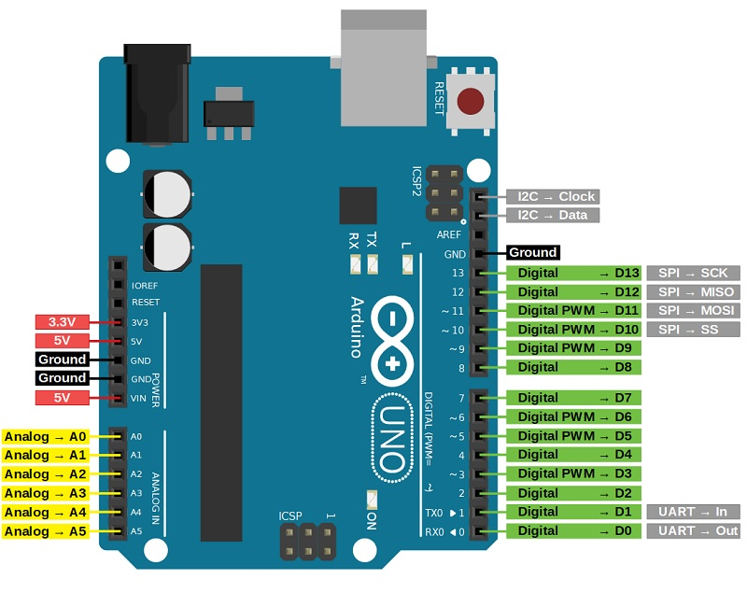Ideal for advanced-level A/D applications in automotive, industrial appliances, and consumer electronics.

Fig 5.2 ARDUINO MICROCONTROLLER

**5.3 CAPACITOR (3 pF)**

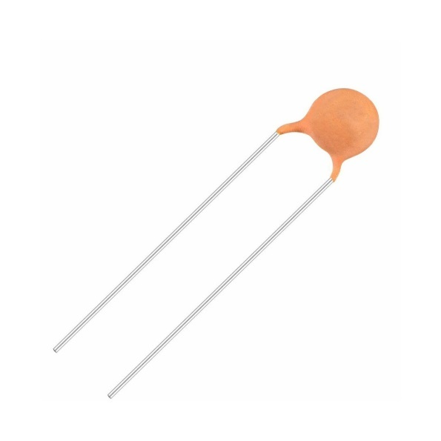A capacitor stores electrical energy and is widely used for filtering, tuning, and coupling signals. A 3-pF capacitor is very small and mainly used in high-frequency circuits like RF and microwave systems to precisely control signal behaviour.

In IRS unit cells, 3 pF capacitors help tune the resonant frequency, enabling precise phase control of reflected waves. This tuning improves beam steering and signal efficiency by adjusting how the surface reflects wireless signals.

**5.4 INDUCTOR (6 nH)**

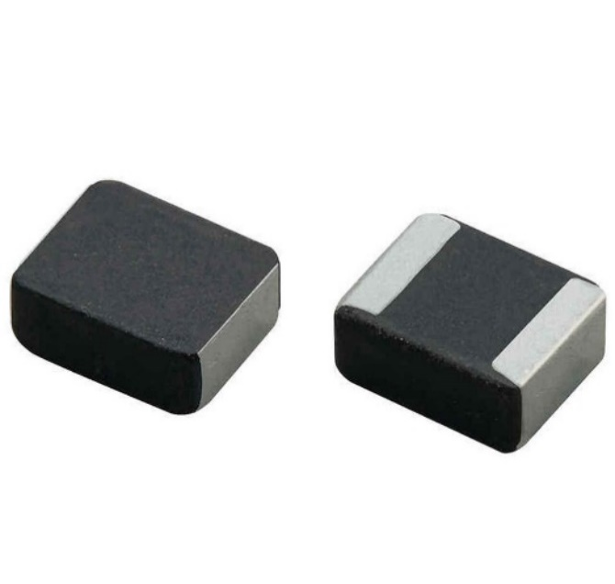An inductor stores energy in a magnetic field and is used in tuning and filtering circuits. A 6 nH inductor is very small and used at high frequencies to shape signal response and create resonant circuits with capacitors.

The 6 nH inductor works with capacitors in each IRS unit cell to control the phase and amplitude of reflected signals. Together, they form LC circuits that enable dynamic beam steering and help filter unwanted frequencies for clearer signals.

**5.5 VARACTOR DIODE**

A varactor diode acts as a voltage-controlled capacitor, with capacitance changing based on applied reverse voltage. It is used in tuning circuits like oscillators and filters without mechanical parts.

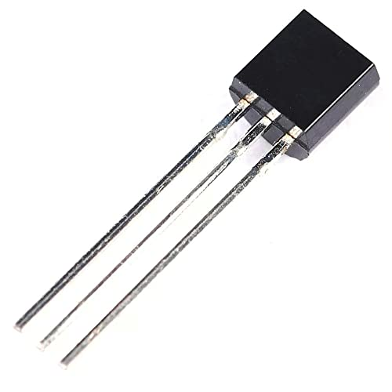Varactor diodes allow real-time tuning of IRS unit cells by varying capacitance through control voltage, changing the phase of reflected waves. This makes the IRS adaptable, enabling dynamic beamforming and improving wireless communication without moving parts.

**5.6 IRS PANEL**

An **IRS (Intelligent Reflecting Surface) panel with tunable elements** is a key component in next-generation wireless communication systems, particularly in 6G, mm Wave, and IoT networks. It is designed to control the propagation of electromagnetic waves in the environment **without requiring active transmission**. Instead, it **manipulates the reflection** of incident signals using passive or semi-passive electronic elements integrated into its surface.

**What is an IRS Panel?**

An IRS panel is a **planar array** made up of many tiny units called **meta-atoms** or **unit cells**, typically organized in a 2D grid. Each unit cell acts like a small antenna or reflector that can **adjust the phase, amplitude, or polarization** of the reflected electromagnetic wave.

**Tunable Elements in IRS**

The **tunable elements** embedded within each unit cell allow the IRS to dynamically alter the way it reflects signals. These components include:

* **Varactor diodes** (voltage-controlled capacitors)
* **PIN diodes** (used for switching on/off or between states)
* **MEMS switches** (micro-electromechanical systems)
* **Graphene-based or ferroelectric materials** (for phase change properties)

Each element responds to a **control signal** (usually a DC bias voltage) from an external controller, changing its electrical properties and, thus, the behaviour of the reflected signal.

**Applications in Wireless Networks**

* **Coverage Extension**: Redirect signals into dead zones or hard-to-reach areas (e.g., around buildings or obstacles).
* **Interference Management**: Cancel or redirect interfering signals to improve signal-to-noise ratio.
* **Energy Efficiency**: Unlike traditional relays or repeaters, IRS panels are mostly passive and consume very little power.
* **Security**: IRS can reflect signals selectively to limit eavesdropping risks.
* **Beamforming**: Works alongside MIMO systems to enhance directional transmission.

**Key Advantages**

* **Low Power Consumption**: Passive or semi-passive components require minimal energy.
* **Cost-Effective Deployment**: Can be installed on walls, ceilings, or infrastructure without active RF components.
* **Real-Time Reconfigurability**: Enables adaptive behaviour based on changing network conditions.
* **Compact Design**: Easily integrated into indoor or outdoor environments.

**Example: Using Varactor Diodes**

If each unit cell contains a **varactor diode**, applying a different bias voltage changes its capacitance. This, in turn, shifts the resonant frequency and **alters the phase** of the reflected wave. By tuning these diodes across the panel, the entire surface can control the reflection pattern of RF waves dynamically.

**5.7 RF TRANSMITTER & RECEIVER**

An **RF (Radio Frequency) Transmitter and Receiver** system is used to **send and receive data wirelessly** through radio waves. It is a fundamental part of wireless communication systems such as Wi-Fi, Bluetooth, GPS, RFID, remote controls, and 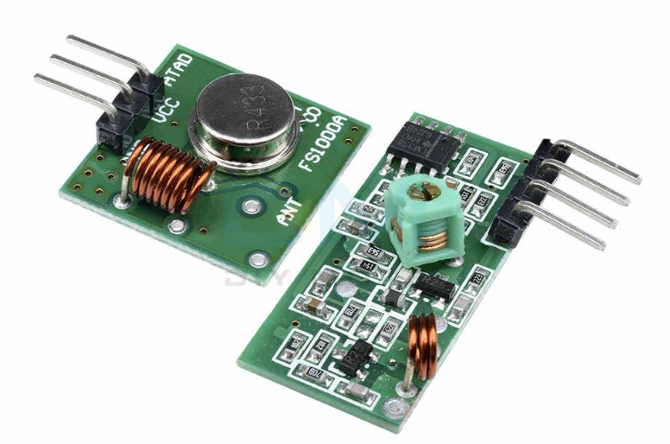IoT devices.

**Fig 5.7 RF Transmitter and Receiver**

**5.7.1 RF TRANSMITTER**

An **RF (Radio Frequency) transmitter** is a crucial component in wireless communication systems. It is responsible for converting data—such as audio, video, or digital signals—into electromagnetic waves that can travel through the air to a remote receiver. This enables devices to communicate wirelessly without the need for physical connections.

The process starts with an **oscillator**, which generates a stable carrier signal at a fixed radio frequency. This carrier wave acts as the foundation for transmitting data. A **modulator** then impresses the actual information onto the carrier wave by altering its amplitude, frequency, or phase, depending on the chosen modulation technique. Common modulation methods include AM, FM, PSK, and FSK.

Once the data is modulated, it is sent through a **power amplifier** to increase the strength of the signal. This is necessary to ensure the signal can travel long distances without significant loss or distortion. The amplified signal is then fed to an **antenna**, which converts the electrical signal into electromagnetic waves and radiates them into the air.

RF transmitters are used in a wide range of applications including mobile phones, Wi-Fi networks, radio broadcasting, satellite communication, and IoT systems. They provide the essential link that enables wireless data transfer between devices in personal, commercial, and industrial environments.

**5.7.2 RF RECEIVER**

An **RF receiver** is the counterpart to the RF transmitter. It captures radio signals from the environment and processes them to recover the original information that was transmitted. Receivers play a vital role in any wireless system, as they make it possible to decode and use the data sent through radio waves.

The first stage of reception involves an **antenna**, which picks up the electromagnetic wave and converts it back into a weak electrical signal. This signal often contains unwanted noise and interference, so it is passed through a **band-pass filter** that isolates the desired frequency range while rejecting others.

After filtering, the signal enters a **low-noise amplifier (LNA)**. This component boosts the strength of the weak incoming signal with minimal addition of noise, improving the clarity and quality of the signal for further processing.

Next, a **demodulator** extracts the original data from the modulated carrier wave. Depending on how the data was modulated by the transmitter, different demodulation techniques are used. Finally, a **decoder** converts the demodulated signal into a usable format, such as audio, video, or digital data.

RF receivers are widely used in everyday devices like smartphones, televisions, radios, and wireless sensors. They are also essential in advanced communication systems, where they must function reliably in environments with interference, multiple signals, and variable conditions. In modern designs, receivers can be enhanced using technologies like **Intelligent Reflecting Surfaces (IRS)**, which help redirect and strengthen signals for better performance in complex wireless environments.

**5.8 TOWER**

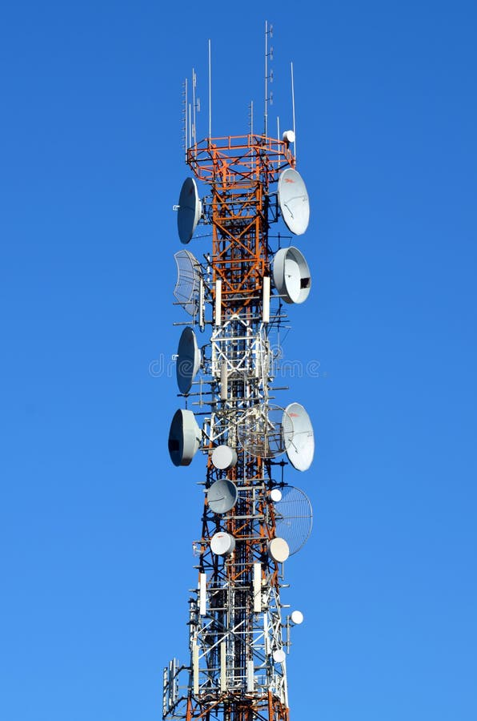

A communication tower is an essential infrastructure component in wireless communication systems, designed primarily to elevate antennas and other transmission devices above the surrounding terrain to maximize signal coverage and quality. These towers enable effective transmission of radio frequency (RF) signals for cellular networks, television broadcasting, radio stations, and emergency communication services.

The structural design of communication towers must consider several critical factors, including material selection, load-bearing capacity, wind resistance, and seismic stability. Most towers are constructed using galvanized steel due to its high strength-to-weight ratio and resistance to corrosion, which ensures longevity and minimal maintenance.

The height of the tower is a significant parameter that influences the line-of-sight range and overall network efficiency, necessitating careful site surveys and engineering calculations before installation. Furthermore, safety features such as lightning protection, grounding systems, and access ladders are integrated into the design to safeguard both the equipment and maintenance personnel.

This project focuses on the comprehensive design and analysis of a communication tower to optimize its structural integrity and functional performance, supporting the deployment of advanced wireless technologies such as 5G and Internet of Things (IoT) networks. Through finite element modelling and simulation, the tower’s response to dynamic loads such as wind gusts and seismic forces is evaluated to ensure compliance with international engineering standards.

**5.9 ANTENNA**

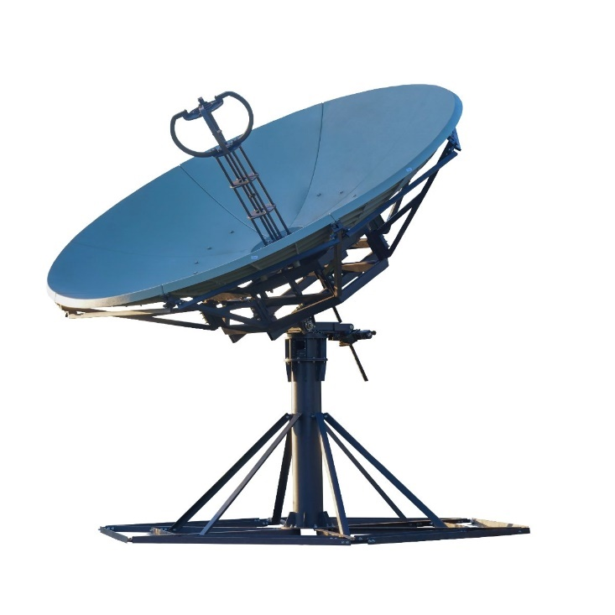An antenna is a fundamental element in any wireless communication system, serving as the interface between the radio frequency (RF) circuitry and the free space through which signals propagate. Its primary function is to efficiently radiate RF energy into the environment during transmission and to collect RF energy during reception with minimal loss. The design of an antenna depends heavily on its intended frequency band, application, and operational environment.

Antennas are classified into various types based on their shape, size, and radiation characteristics. Common types include dipole antennas, which are simple and widely used for many applications; monopole antennas, which are a variation of dipoles mounted above a ground plane; patch antennas, which are compact and suitable for integration into devices; and phased array antennas, which can electronically steer the direction of the signal beam without physically moving the antenna.

Key parameters that define antenna performance include gain, which measures how well the antenna directs energy in a particular direction; directivity, which describes the concentration of radiated power; polarization, indicating the orientation of the electromagnetic waves; bandwidth, the range of frequencies over which the antenna operates effectively; and radiation pattern, which illustrates the spatial distribution of radiated power. Understanding and optimizing these parameters is crucial to improving communication range, signal strength, and resistance to interference.

The placement and orientation of antennas significantly impact the quality of wireless communication. Factors such as height above ground, proximity to obstacles, and alignment with other antennas are carefully considered during installation to maximize coverage and minimize signal degradation.

Modern communication systems, including cellular networks, Wi-Fi, satellite links, and emerging technologies like 5G and the Internet of Things (IoT), rely heavily on advanced antenna designs. Innovations such as Multiple Input Multiple Output (MIMO) antennas and beamforming techniques enhance data throughput and spectral efficiency by enabling simultaneous transmission and reception of multiple data streams.

In this project, the design and analysis of antennas form a crucial part of developing an efficient wireless communication system. Simulation tools and experimental validations are employed to optimize antenna parameters and ensure compatibility with the overall network architecture.

**CHAPTER 6**

**SOFTWARE REQUIREMENTS**

The software used in this project is listed below.

1. COMSOL Multiphysics 6.3
   1. **INTRODUCTION OF THE SOFTWARE**

**COMSOL Multiphysics** is a powerful simulation software designed for modelling and solving complex engineering problems involving Multiphysics phenomena. It provides a flexible and integrated environment for simulating a wide range of physical processes such as structural mechanics, electromagnetics, fluid dynamics, heat transfer, and chemical reactions. The software employs finite element analysis (FEA) and allows users to couple multiple physical domains within a single simulation, offering accurate and comprehensive results. With an intuitive user interface, extensive material libraries, and customizable modules, COMSOL enables researchers, engineers, and scientists to prototype designs, optimize systems, and predict real-world performance efficiently. It also supports scripting and custom application development, making it highly versatile for both academic research and industrial applications.

* + 1. **SYSTEM COMPONENT**
       1. **COMSOL Desktop Environment**

This is the graphical user interface (GUI) where users build models, define parameters, and analyse results. It provides tools for geometry creation, meshing, physics selection, solvers, and post-processing—all integrated in a user-friendly workflow.

* + - 1. **Physics Interfaces**

These are predefined application modules that include governing equations, boundary conditions, and material properties for specific physical domains. Examples include:

* **Electromagnetic Waves (RF Module)** – for microwave and antenna simulation.
* Heat Transfer Module
* Structural Mechanics Module
* Acoustics Module, etc.
  + - 1. **Multiphysics Coupling**

Allows the user to combine multiple physics in a single model. For instance, simulating electromagnetic behaviour with thermal effects or structural deformation, which is useful for analysing IRS materials under different environmental conditions.

* + - 1. **Geometry and CAD Tools**

Built-in tools to create 1D, 2D, and 3D geometries or import from CAD software. Users can define complex structures like meta surfaces used in IRS design.

* + - 1. **Meshing Tool**

Enables automatic and manual generation of high-quality meshes, crucial for accurate finite element analysis (FEA).

* + - 1. **Study and Solver Configurations**

Includes a wide range of solvers (direct and iterative) for both linear and nonlinear problems. Time-dependent and frequency-domain studies are available, making it ideal for electromagnetic wave simulations.

* + - 1. **Postprocessing and Visualization**

Tools to visualize simulation results—such as electric field distributions, S-parameters, surface currents, and power flows—using plots, animations, and numerical data export.

* + - 1. **Application Builder**

Let’s users create custom simulation apps with simplified user interfaces. This is useful for sharing models with colleagues or for specific design use cases without exposing the full COMSOL environment.

* + - 1. **LiveLink Interfaces**

Integration with third-party tools like MATLAB®, SolidWorks®, AutoCAD®, and Excel® for enhanced modelling, control, and data manipulation

* + - 1. **Material Library**

A comprehensive database of material properties (dielectric constants, conductivity, permeability, etc.) that can be directly used in simulations.

* 1. **APPLICATION OF THE SOFTWARE**

COMSOL Multiphysics is widely used across engineering, physics, and scientific research fields for simulating and analysing complex systems involving multiple physical interactions. In **electromagnetics**, it is applied for antenna design, RF component analysis, wave propagation, and electromagnetic compatibility (EMC) studies. In **mechanical engineering**, it supports structural analysis, stress-strain evaluations, and vibration simulations. The software is also used in **thermal analysis** to model heat transfer in solids, fluids, and through radiation. In **fluid dynamics**, it aids in simulating laminar, turbulent, and multiphase flows. COMSOL is especially valuable in **Multiphysics scenarios**, such as simulating how thermal expansion affects electronic circuits or how electromagnetic waves interact with mechanical structures. It is extensively used in industries like telecommunications, aerospace, biomedical engineering, automotive, energy, and academic research for product design, performance optimization, and theoretical analysis.

1. **Electromagnetics:**
   * Antenna design
   * RF component analysis (filters, waveguides, etc.)
   * Electromagnetic wave propagation
   * Electromagnetic compatibility (EMC) and interference analysis
   * Wireless communication systems (including IRS and MIMO systems)
2. **Structural Mechanics:**
   * Stress and strain analysis
   * Vibration analysis
   * Structural optimization
   * Thermal and mechanical coupling (e.g., thermal expansion in structures)
3. **Heat Transfer:**
   * Thermal conductivity and heat distribution
   * Conduction, convection, and radiation heat transfer
   * Thermal management in electronic devices
4. **Fluid Dynamics:**
   * Laminar and turbulent flow simulations
   * Multiphase flow analysis
   * Fluid-structure interaction (FSI)
   * Heat exchangers and fluid transportation systems
5. **Acoustics:**
   * Sound wave propagation and absorption
   * Acoustical design for rooms, engines, and audio systems
   * Acoustic-structural interactions
6. **Chemical Engineering:**
   * Chemical reaction engineering
   * Fluid flow in chemical reactors
   * Diffusion and mass transport processes
7. **Biotechnology and Biomedical Engineering:**
   * Modelling of biological systems (e.g., drug delivery, tissue engineering)
   * Medical device simulation (e.g., stents, prosthetics)
   * Biochemical reaction modelling
8. **Multiphysics Simulations:**
   * Coupled physics simulations (e.g., electromagnetic-thermal, structural-thermal)
   * Electromagnetic-structural interaction (for sensors, MEMS devices)
   * Electrochemistry and thermo-mechanics in battery design
9. **Semiconductor Design:**
   * Microelectromechanical systems (MEMS)
   * Integrated circuit modelling
   * Photonic and optoelectronic devices
10. **Energy Systems:**
    * Renewable energy (solar, wind)
    * Heat pumps, geothermal systems
    * Power electronics and grid integration
11. **Manufacturing and Process Design:**
    * Additive manufacturing (3D printing)
    * Simulation of manufacturing processes (e.g., casting, welding).
    1. **FUNCTIONS**
12. **Modelling and Simulation**

COMSOL Multiphysics enables users to create 1D, 2D, and 3D models to simulate a wide range of physical phenomena, including structural, thermal, fluidic, and electrical systems.

1. **Multiphysics Coupling**

The software allows for seamless coupling of different physical processes, such as fluid-structure interaction or electromagnetic-thermal coupling, where multiple physics interact within a single model.

1. **Finite Element Analysis (FEA)**

Using finite element analysis (FEA), COMSOL solves partial differential equations to deliver accurate spatial and temporal analysis, supporting both linear and nonlinear problems in steady-state or transient conditions.

1. **Parametric and Optimization Studies**

COMSOL offers powerful tools for performing parametric sweeps, allowing users to study the influence of varying parameters. It also supports automatic optimization of designs based on defined performance objectives.

1. **CAD and Geometry Tools**

The software includes tools to create custom geometries or import CAD models from other software like SolidWorks and AutoCAD. These tools help generate high-quality meshes for solving complex problems.

1. **Postprocessing and Visualization**

COMSOL provides a range of postprocessing functions to visualize simulation results using 2D and 3D plots, animations, and contour plots, making it easier to analyse and interpret data.

1. **Material Property Library**

COMSOL includes a comprehensive material library with predefined properties for various materials. It also allows users to define custom material properties for specialized simulations.

1. **Application Builder**

The Application Builder enables users to create custom simulation applications with simplified user interfaces, streamlining the deployment of models and making them easier to use by others.

1. **LiveLink Integration**

Through LiveLink, COMSOL integrates with external software like MATLAB, Simulink, and Excel. This enhances the functionality of simulations, allowing for advanced data handling and custom scripting.

1. **Real-Time Simulation and Control**

COMSOL supports real-time simulation and control, particularly useful for systems like MEMS (Micro-Electromechanical Systems) or mechatronic applications, enabling real-time monitoring and feedback.

1. **Simulation of Manufacturing Processes**

The software also simulates various manufacturing processes, such as casting, welding, and additive manufacturing (3D printing), predicting material behaviour during production and optimizing designs for manufacturability.

**CHAPTER 7**

**SYSTEM IMPLEMENTATION**

* 1. **SYSTEM IMPLEMENTATION**

[COMSOLlink[]]The **Intelligent Reflecting Surface (IRS)** is a passive meta surface technology that enhances wireless communication by dynamically controlling the reflection and direction of electromagnetic waves. Unlike active elements such as RF amplifiers, IRS does not generate or amplify signals—it simply **manipulates the propagation of incident waves** to optimize performance in wireless networks like **5G and future 6G systems**.

**Fig 7.1 IRS PANEL**

**1. Architecture and Components**

The IRS system consists of the following key components:

* **Meta surface Panel:** The core structure of the IRS is a **passive reflective array** made of reconfigurable unit cells. Each unit cell adjusts its **reflection phase** using electronic tuning elements like **PIN diodes or liquid crystal materials** to control wave redirection.
* **Control Mechanism:** The IRS operates under external control from **network processors or base stations**. These controllers send configuration signals to modify the phase response of each unit cell.
* [COMSOLlink[]]**Wave Manipulation Strategy:** The system alters electromagnetic wave behaviour using **programmable reflection**, enabling beam steering, interference suppression, and improved signal coverage.

**Fig 7.1.1 Single Element Exploded View**

**2. Passive Beamforming Techniques**

Since IRS does not actively amplify signals, its function relies on **passive beamforming**, where incident signals are **redirected efficiently** to target locations. This is achieved through:

* **Phase Shifting:** Each IRS unit cell modifies the phase of incoming waves to optimize reflection angles.
* **Constructive Interference Engineering:** Signals are redirected in such a way that they reinforce intended transmission paths, improving overall network signal strength.
* **Polarization Adjustment:** IRS elements can manipulate signal polarization to match the receiver’s antenna characteristics.

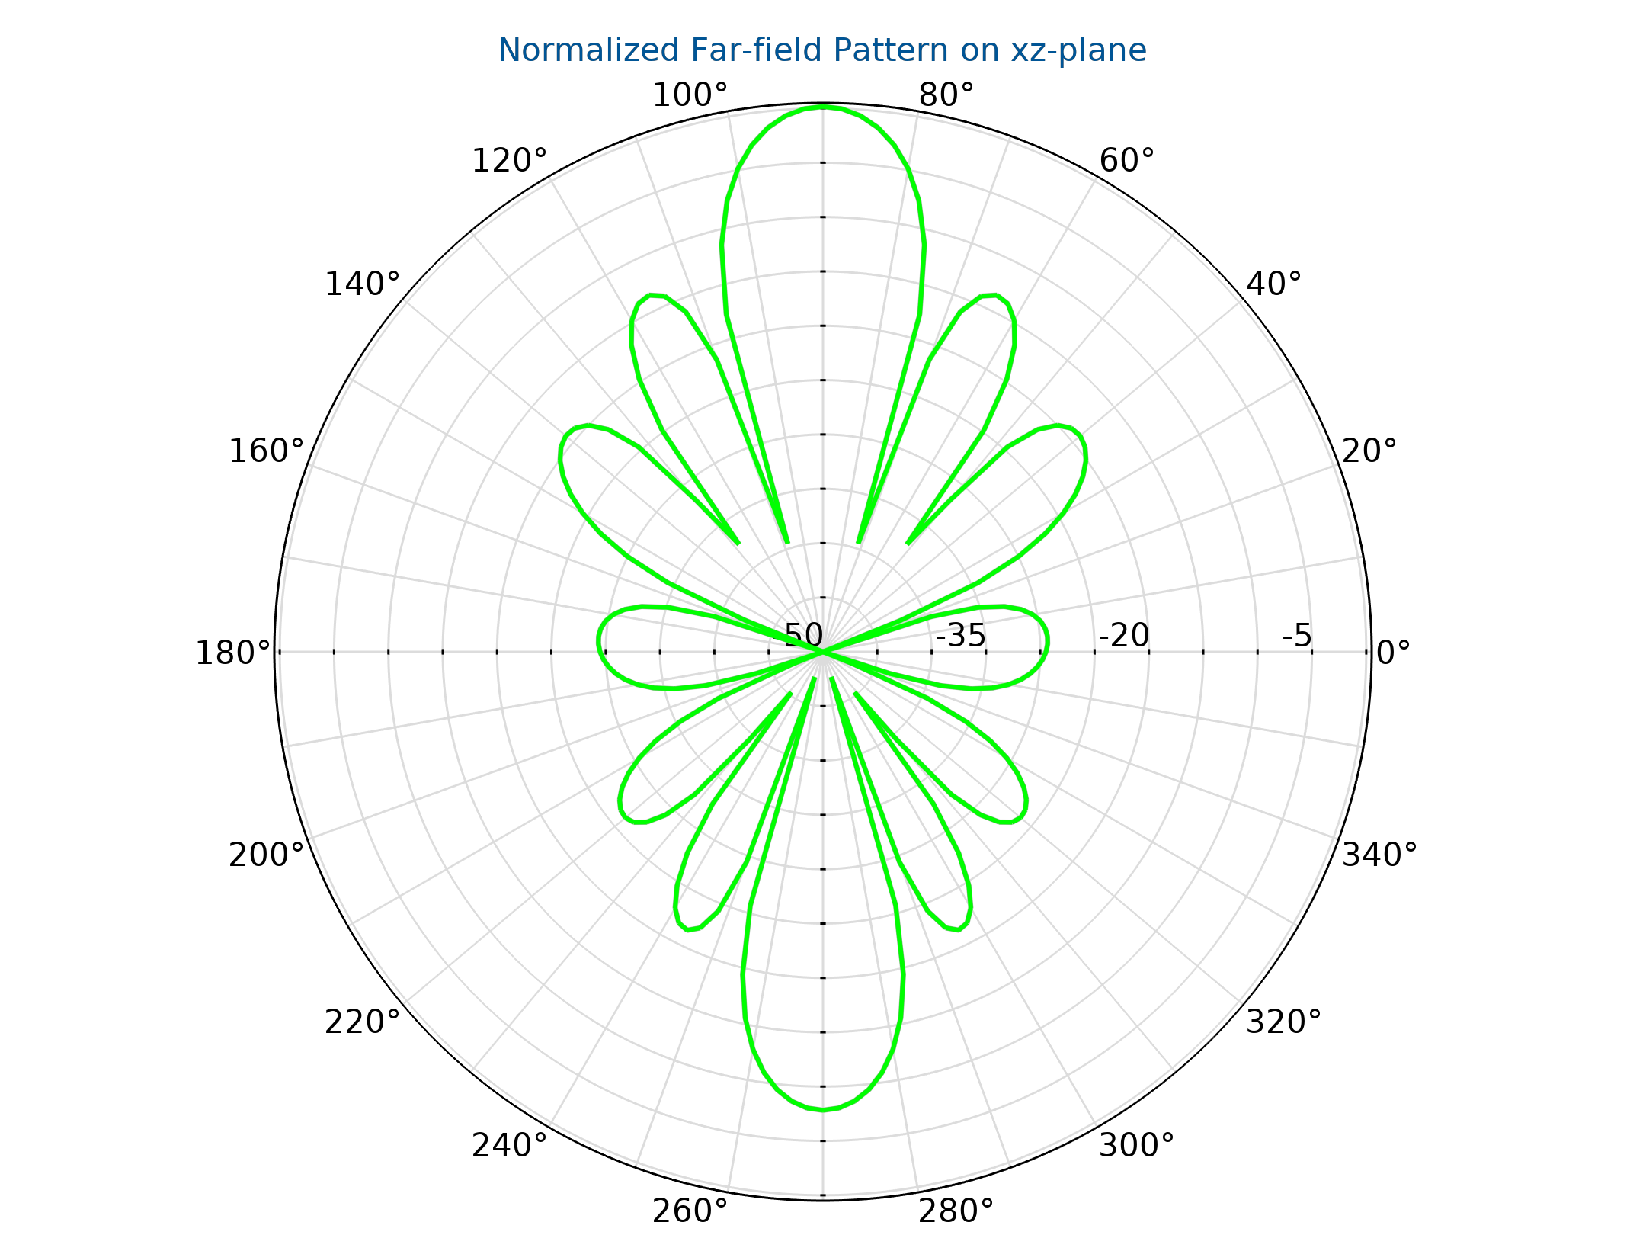

**Fig 7.2.1 Radiation Pattern of the IRS**

**3. Deployment and Network Optimization**

IRS panels are installed at strategic locations to improve network reliability and coverage without requiring additional power sources. Common deployment scenarios include:

* **Building-mounted IRS:** Enhances signal propagation in dense urban environments.
* **Indoor IRS Arrays:** Improves communication in offices, conference rooms, and enclosed spaces.
* **Vehicular IRS Solutions:** Increases mobile network stability by optimizing reflections for moving receivers.

**4. Computational Modelling & Performance Evaluation**

To validate IRS efficiency, simulations are performed using **COMSOL Multiphysics**, **MATLAB**, or **CST Microwave Studio**. Key evaluation metrics include:

* **S-Parameter Analysis (S11):** Measures reflection properties and impedance matching.
* **Radiation Pattern Simulation:** Determines how well IRS redirects signals in different directions.
* **Energy Efficiency Assessment:** Since IRS is passive, power consumption is minimal, making it ideal for **low-energy, high-performance communication networks**.

The **Intelligent Reflecting Surface** is a groundbreaking technology that passively reshapes electromagnetic waves to improve signal reliability and coverage in **5G, 6G, and IoT environments**. By **eliminating the need for power-hungry active components**, IRS offers an energy-efficient solution for **smart wireless networks, autonomous communication, and enhanced spectral efficiency**.

**CHAPTER 8**

**EXPERIMENTAL RESULT AND ANALYSIS**

**CHAPTER 9**

**CONCLUSION**

**CHAPTER 10**

**FUTURE SCOPE**